CONTENT

Page No.

1. Abstract ……………………… 3
2. Introduction ………………….. 4
3. Overview of the System ………. 5
4. Functional Requirements ……… 6
5. Non-Functional Requirements … 7
6. Methodology ………………… 8-12
   1. Entity Relationship Diagram… 9
   2. Data Flow Diagram………... 10
   3. Data Modelling …...……… 11-12
7. Implementation ………………… 13-14
8. Software Used ...………………... 13-14
   1. Ordering System ……….... 14
   2. Review System ………… 14

9.Result and Discussion …………. 15-16

* 1. Scope of Improvement ……… 15-16
  2. Scope of future application … 16
  3. Screenshots of the website …

1. Conclusion …………………. 17
2. References …………………… 17

Abstract

Web development is the work involved in developing a website for the Internet (World Wide Web) or an intranet (a private network). Web development can range from developing a simple single static page of plain text to complex web applications, electronic businesses, and social network services. A more comprehensive list or tasks to which Web development commonly refers, may include Web engineering, Web design, Web content development, client liaison, client-side/server-side scripting, web server and network security configuration, and ecommerce development. Among Web professionals, "Web development" usually refers to the main non-design aspects of building Web sites: writing markup and coding. Web development may use content management systems (CMS) to make content changes easier and available with basic technical skills.

For larger organizations and businesses, Web development teams can consist of hundreds of people (Web developers) and follow standard methods like Agile methodologies while developing Web sites. Smaller organizations may only require a single permanent or contracting developer, or secondary assignment to related job positions such as a graphic designer or information systems technician.

Basic web pages can be created using HTML, CSS, and JavaScript. While it is not essential to use all three of these in one webpage, they can be used in conjunction with each other to make dynamic webpages. There are many open-source tools for Web development such as BerkeleyDB, GlassFish, LAMP (Linux, Apache, MySQL, PHP) stack and Perl/Plack

Introduction

National Hardware Mart is an ecommerce website that specializes in providing a wide range of hardware products to customers across the country. Our platform offers a convenient and user-friendly shopping experience that allows customers to easily browse, and purchase products from a variety of categories such as electrical, plumbing, tools, and hardware accessories. Our mission is to provide our customers with high-quality products at competitive prices while delivering exceptional customer service and support.

Our ecommerce platform offers a comprehensive set of features and functionality to meet the needs of our customers. This software requirements specification (SRS) document outlines the requirements for the National Hardware Mart ecommerce website. It is intended to provide a clear and detailed understanding of the system's capabilities, limitations, and constraints. The document outlines both functional and non-functional requirements for the system.

The system was carefully designed to ensure maximum efficiency of the system. The limited time and resources have restricted us to incorporate, in this project, only main activities that are performed in an e-commerce website, but utmost care has been taken to make the system user-friendly.

Bottom of Form

Overview Of the System:

National Hardware Mart is an e-commerce platform that specializes in selling hardware products online. The website aims to provide a convenient and hassle-free shopping experience for customers who are looking for high-quality hardware products. The website will have a wide range of hardware products, including but not limited to, power tools, hand tools, spare tools, plumbing, and heavy machinery.

The website will allow users to browse and search for products, add them to their cart, and complete the purchase using a secure payment gateway. The website will also have features like account creation, and customer support to ensure a seamless user experience.

To provide the best possible experience to the users, the website will have a user-friendly interface, with clear and concise product descriptions, high-quality images, and user reviews. The website will also be optimized for fast loading speeds.

The entire information has been maintained in the database or files and only authorized users can retrieve the necessary information which can be easily accessible from the file. The front page of the website is also dynamic and appears more pleasant and attractive to the eyes.

Overall, National Hardware Mart aims to provide a comprehensive online hardware shopping experience to its customers, with a wide range of products, user-friendly interface, and top-notch customer service.

Top of Form

Functional Requirements:

The functional requirements of the website are as follows:

1. **User Registration:**

The website will provide a user registration system that will allow users to create an account on the website. Users will be required to provide their personal details such as name, email, phone number and a password.

1. **Product Catalogue:**

The website will provide a product catalogue that will allow users to browse products by category and search for products by name.

1. **Product Details:**

The website will display detailed information about each product, including product name, description, price, and images.

1. **Shopping Cart:**

The website will provide a shopping cart system that will allow users to add products to their cart, view their cart, and update their cart.

1. **Checkout:**

The website will provide a checkout system that will allow users to complete their purchases. The checkout process will include a payment gateway integration that will allow users to pay for their purchases using a credit card, cash on delivery and upi payment methods.

Non-Functional Requirements:

The non-functional requirements of the website are as follows:

* The home page must contain a navigation bar.
* The login button must be displayed and if the user is not logged in then they must register.
* The website should have a user-friendly interface that is easy to navigate.
* The website's colour scheme and contrast are designed with consideration for users with disabilities, in order to ensure that the site is accessible and easy to use for a broad range of users.

Methodology:

A basic flowchart of how the user can use the system is as follows:

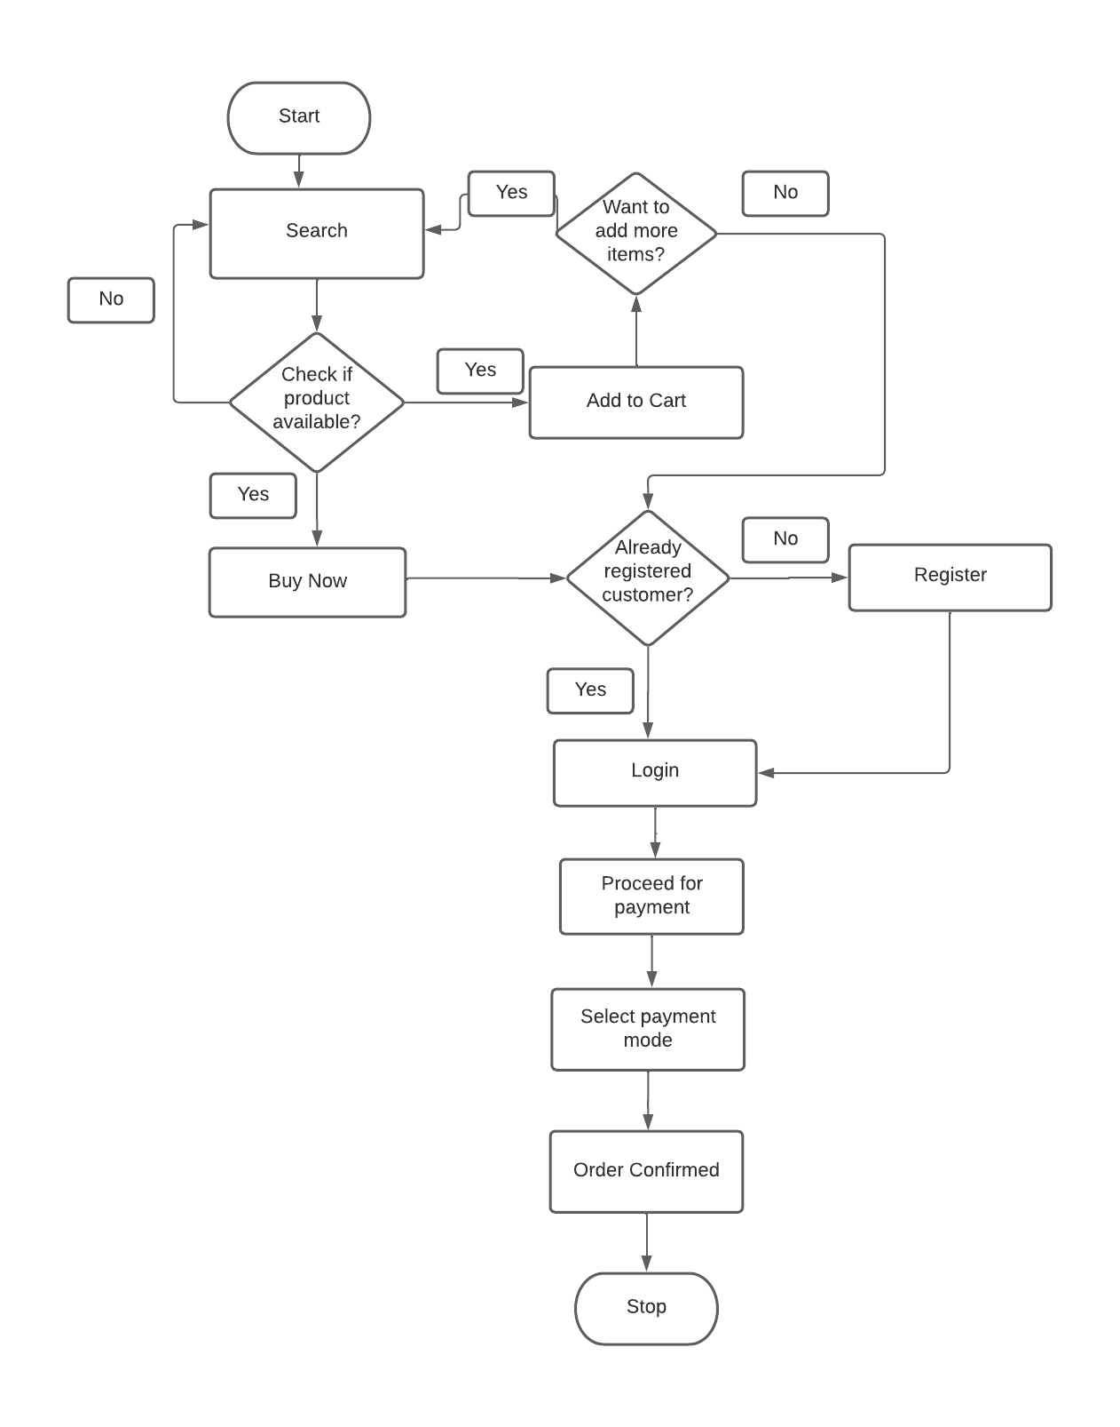

* Entity Relationship Diagram:

ER Diagram stands for Entity Relationship Diagram. also known as ERD. It is a diagram that displays the relationship of entity sets stored in a database. In other words, ER diagrams help to explain the logical structure of databases. ER diagrams are created based on three basic concepts: entities, attributes and relationships.ER Diagrams contain different symbols that use rectangles to represent entities, ovals to define attributes and diamond shapes to represent relationships. An ER diagram looks very similar to the flowchart. However. ER Diagram includes many specialized symbols, and its meanings make this model unique. The purpose of ER Diagram is to represent the entity framework infrastructure.

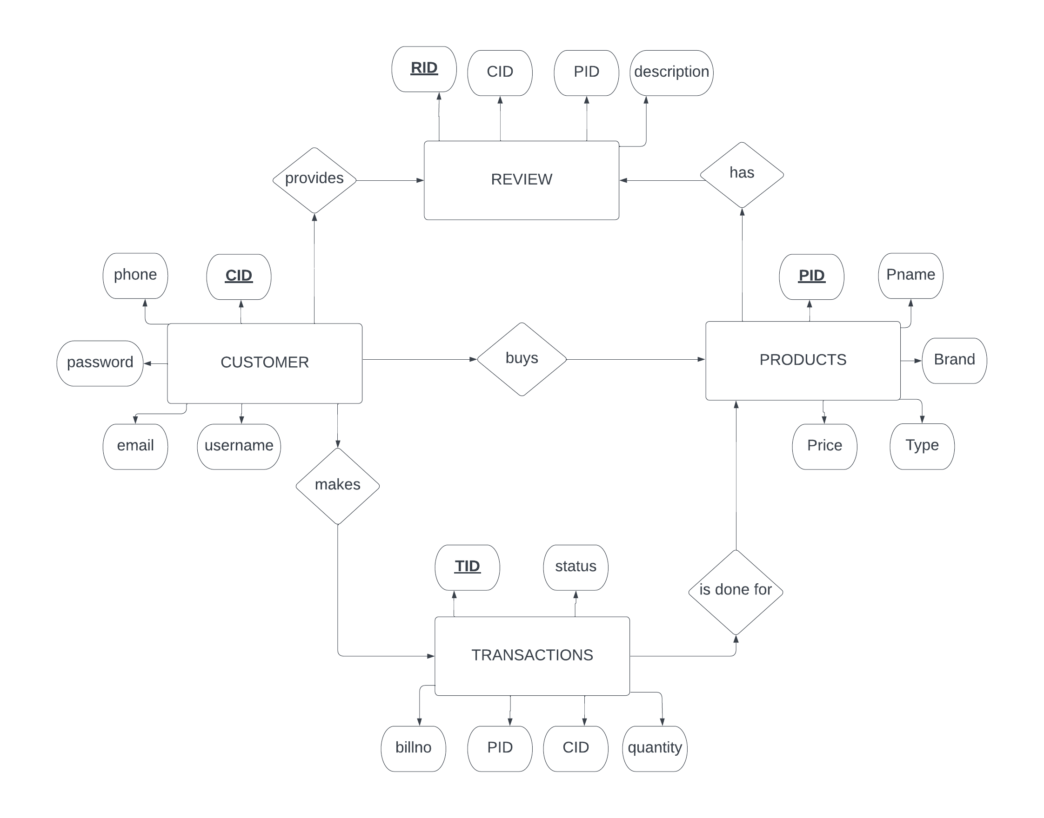

* Data Flow Diagram (DFD):

The flow of data of a system or a process is represented by a DFD. It also gives insight into the inputs and outputs of each entity and the process itself. DFD does not have control flow and no loops or decision rules are present. Specific operations depending on the type of data can be explained by a flowchart. Data Flow Diagrams are very popular because they help us to visualize the major steps and data involved in the software processes. The importance of Hardware Website System DFD (Data Flow Diagram) is that it helps the audience in understanding what is happening in the system. Also, how the system manages its data at different levels of detail. It is one of the methods used for development. It represents the system's major processes, and alternatives that generate the flow of data within the system. Moreover, the data includes in Data Flow Diagram labelled properly to guide the developers on the structure of the website.

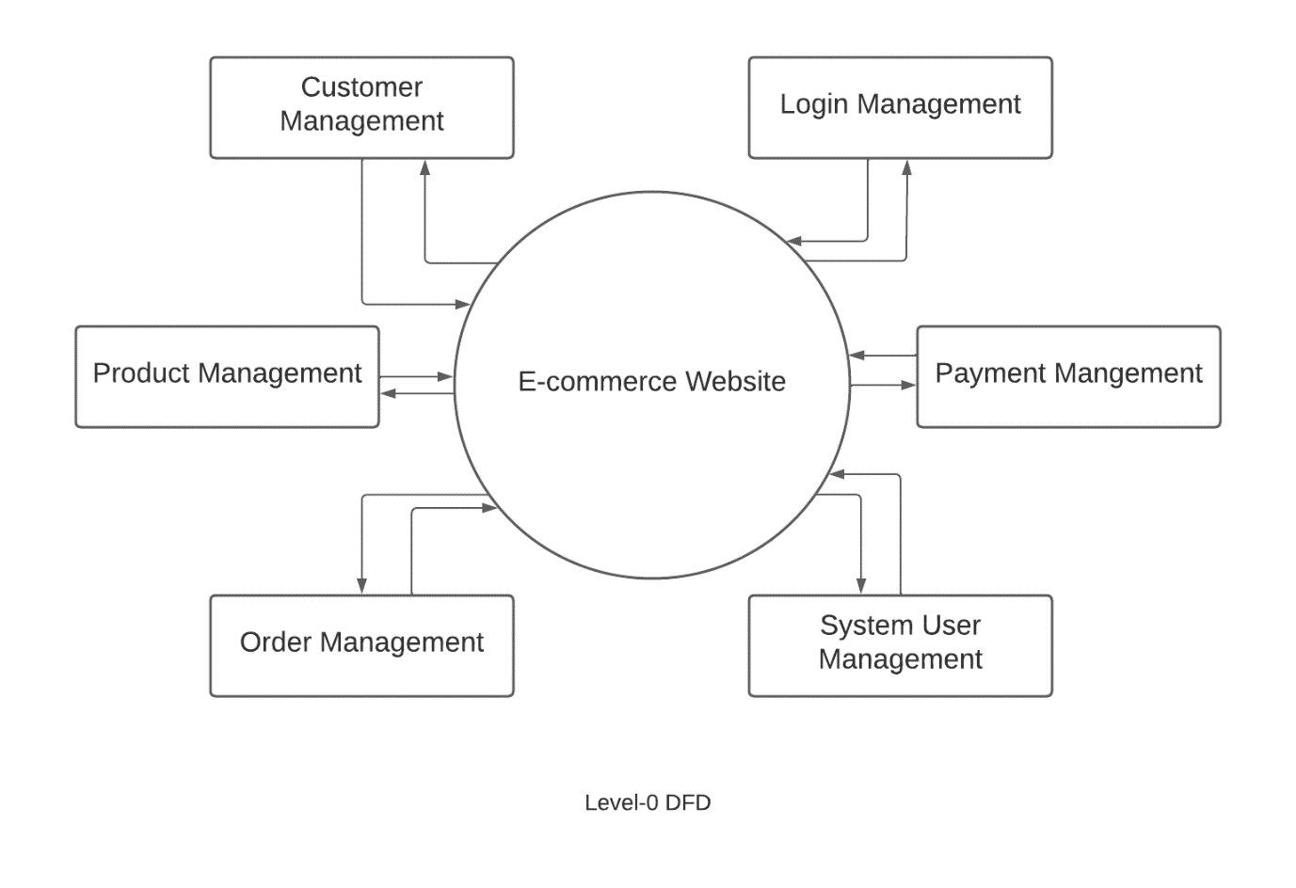

* Data Modelling:

Data models define how the logical structure of its database is modelled. They are fundamental entities to introduce abstraction in a DBMS. They define how data is connected to each other and how they are processed and stored inside the system. The goal of data modelling is to produce high quality, consistent, structured data for running business applications and achieving consistent results.

* Table customer

|  |  |
| --- | --- |
| Fields | Types |
| cid | int (Primary Key ) |
| username | varchar |
| phone | bigint |
| email | varchar |
| password | varchar |

* Table product

|  |  |
| --- | --- |
| Fields | Types |
| pid | int (Primary Key ) |
| pname | varchar |
| type | varchar |
| brand | varchar |
| price | decimal |

* Table review

|  |  |
| --- | --- |
| Fields | Types |
| rid | int (Primary Key ) |
| description | varchar |
| pid | Foreign Key |
| cid | Foreign Key |

* Table transactions

|  |  |
| --- | --- |
| Fields | Types |
| tid | int (Primary Key ) |
| status | varchar |
| billno | int |
| quantity | varchar |
| pid | Foreign Key |
| cid | Foreign Key |

Implementation

* Software Used:

The various software used to implement this project are as follows:

*  **HTML** (Hypertext Markup Language) and **CSS** (Cascading Style Sheets) are two of the core technologies for building web pages. While HTML provides the structure of the webpage, CSS provides the visual and aural layout for a variety of devices. In this project, HTML has been used to structure the page into elements such as paragraphs, sections, headings, navigation bars and so on.CSS has been used to layout elements by positioning them in specified areas of the page. With CSS the colour and background of the elements, as well as, the typeface, margins, spacing and padding have been set.
* **JavaScript**, often abbreviated as JS is a programming language that is one of the core technologies the World Wide Web, alongside HTML, and CSS, used both on the client-side and server-side to make web pages interactive. JS here has been used to program the actions, conditions, calculations, network requests, concurrent tasks, and many other kinds of instructions to make the web page react in a certain way.
* **PHP** is a server-side scripting language that is used to create dynamic web pages that can interact with database. It is a widely used open-source language that is specifically used in web application development and can be embedded within HTML.
* **MySQL** is an open-source relational database management system (RDBMS). SQL is abbreviated for Structured Query Language. A relational database organizes data into one or more data tables in which data may be related to each other, these relations help structure the data. SQL is a language programmers use to create, modify, and extract data from the relational database as well as control user access to the database. In addition to relational databases and SQL an RDBMS like MySQL works with an operating system to implement a relational database in a computer’s storage system, manages users, allows for network access and facilities testing database integrity and creation of backups. MySQL has been used to create the database where the records have been stored.
* Ordering System:

If a user visits the website to order an item and if he/she is not an already registered customer, they can scroll and see the products available as well as search for products but in order to order a product he/she will have to sign up by entering their username, email, phone and create a password. Once registered the customer can now login and add a product to cart. If the customer is already registered, he/she can login using their username and password, and they can search their desired product and can either add it to Wishlist or can add it to cart, from where they can select the quantity, and procced for payment section where they can choose their payment method and confirm the order.

* Review System:

A person can also provide review for a particular product. Hence helping other customers who are planning to buy the same item. Each product has its own review form (from where review can be added), and a review section to read about a particular product.

Result and Discussion:

The website, National Hardware Mart is simple to use, like any other e-commerce website. The system gives error message as and when required, for example, if email or password input is wrong. It is easy to find the products through categories or using the keyword in the search bar. The user can also provide review for any product. He/she can also visit the social media pages of `National Hardware Mart` to get more news about the new products. The icons on the website home page makes it easy for user to navigate the website. However, limited time and resources have restricted us to incorporate, in this project, only main activities that are performed in an E-Commerce Website.

* Scope of Improvement:

1. Work on optimizing the website loading speed and making it more responsive to user actions.
2. Expanding the range of products offered on the website to attract a wider customer base by adding new categories, products, and brands that are relevant.
3. Enhancing the security features of the website to protect user information and prevent hacking attempts by using SSL encryption, implementing two-factor authentication, and regularly updating software and plugins to prevent vulnerabilities.Top of Form
4. A chatbot can be introduced for customer assistance and to answer frequently asked questions (FAQs).
5. A recommendation system can be added in order to help the customers know about the best-selling products and items that are frequently bought together.
6. Feedback can be gathered from customers through surveys, reviews, and social media channels. This feedback can be used to identify areas of improvement and make necessary changes to the website.

* Scope of future Application:

1. The database of this project, as of now is limited to a few products only but will be updated to make the website on a much larger scale.
2. Order history page can be added in order to let the customer know their product history.
3. Make the website available in different languages apart from English so it’s easy for customers to navigate.
4. Make the cart and Wishlist more convenient for users.
5. As mobile usage continues to increase, creating a mobile application can provide a convenient and streamlined experience for customers to browse and purchase products on the go.
6. Using machine learning algorithms and customer data, personalized product recommendations can be generated for customers based on their browsing and purchasing behaviour, increasing the chances of making a sale.
7. As consumers become more environmentally and socially conscious, incorporating sustainable and socially responsible practices into the business can improve the brand image and attract like-minded customers. This could include features such as eco-friendly product options or charitable donations for each purchase made.
8. A secure online payment methos can be added to ensure confidentiality and a hassle-free payment experience for the customers.

Conclusion:

In conclusion, the National Hardware Mart ecommerce website aims to provide a user-friendly platform for customers to purchase hardware products online. The SRS document has outlined the functional and non-functional requirements of the website, including features such as product browsing, searching, ordering, payment, and shipping. The document also identifies the potential risks and limitations of the website, as well as suggestions for future improvements and applications. Overall, the National Hardware Mart ecommerce website is designed to meet the needs of customers looking for a convenient and reliable way to purchase hardware products online.

References:

1. Hardware Shack: https://hardwareshack.in
2. Indian Hardware: http://www.indianhardwarestores.com
3. India Mart: <https://www.indiamart.com>
4. KnobsKart: <https://knobskart.com>
5. Learning PHP, MySQL, JavaScript and CSS: A Step-by-Step Guide to Creating Dynamic Websites—by Robin Nixon.